**MAKING A FACE RECOGNITION PROGRAM FOR ATTENDANCE**

**Brandon Agusta Wijaya, Lauren Abigail, Jenibelle Wievin, Stanley Raditya**

“Bina Nusantara University, Kemanggisan, School of Computer Science, 11530, Indonesia

Email: [brandon.wijaya002@binus.ac.id](mailto:brandon.wijaya002@binus.ac.id), [jenibelle.weievin@binus.ac.id](mailto:jenibelle.weievin@binus.ac.id), [lauren.abigail@binus.ac.id](mailto:lauren.abigail@binus.ac.id), stanley.raditya@binus.ac.id

**ABSTRACT**

In the contemporary digital era marked by rapid technological advancements, the integration of technology into various facets of daily life is evident. One crucial application is in attendance recording for institutions such as schools, universities, and workplaces. While attendance tracking plays a vital role in monitoring individuals' presence, it faces challenges, particularly fraudulent activities. This research proposes a solution by advocating for the integration of facial recognition technology into attendance systems. Leveraging artificial intelligence advancements, this innovative approach aims to enhance accuracy and efficiency, creating a secure method to verify individuals' presence and minimize fraud. The goal is to contribute to the ongoing development of attendance management technology, making the process seamless, less complex, and resistant to fraudulent practices.

Keywords: Attendance tracking, Facial recognition technology, Artificial intelligence, Fraud prevention, Technological advancements, Educational institutions, Workplace attendance, Seamless attendance management, System integration, Security in attendance recording

**1. INTRODUCTION**

Attendance refers to an individual's presence or participation in a specific activity, and it can be classified into two categories: online and offline. Online attendance is exemplified by the completion of Google Forms during seminars, while offline attendance involves physically attending a meeting or event.

Having grasped the concept of attendance, let's explore the common issues that often plague the attendance process. Firstly, cheating poses a significant challenge, where individuals may resort to forging signatures, using someone else's signature, or employing tools to falsify attendance records. Secondly, inaccuracies in attendance systems can lead to errors in calculating the total number of participants, thereby impacting the overall attendance count. Lastly, inefficient attendance systems can prolong the process, consuming valuable time and disrupting overall productivity.

In light of these challenges, it becomes apparent that there is a pressing need for a solution that is accurate, efficient, and minimizes errors. In the current era of advanced technology, where speed and efficiency are paramount, we have introduced an innovative face recognition program to streamline the attendance process. This technology aims to address the issues of cheating, inaccuracy, and inefficiency, providing a reliable and seamless solution for attendance management in today's fast-paced environment.

**2. LITERATURE REVIEW**

Facial recognition is a way of identifying a human face through technology known as biometrics, oftentimes mapping facial features from a photograph or video and then comparing the information with a database of known faces to find a match. Facial recognition is being used everywhere now and the facial recognition market is growing.

Facial recognition uses technology and biometrics typically through AI – to identify human face structures. It maps our facial features from a photograph or a video then compares the information with a certain database of known faces to find a match. Facial recognition can help us to verify someone’s identity.

Before we start talking about the method, installing and preparing libraries. We’re using an open source computer vision and machine learning software library called OpenCV (Open Source Computer Vision Library)



OpenCV was built to provide us a common infrastructure for computer vision applications and to accelerate the use of machine perception in the commercial products. OpenCV is a popular Computer Vision Library to develop applications built using C++ and C, it has several uses like Object Detection and Video processing. Computer Vision overlaps with field kike Image processing, photogrammetry and pattern recognition. That’s why this library is very important in this project as we need to connect our ‘webcam’ with our program.

As we want to use Python as our main language in this program we need Microsoft Visual Studio and install the “Desktop development with C++”. With this, we can use our OpenCV library and use the OpenCV-python through Conda prompt or virtual environment which we’ll do later.

**Uses of face detection**

Face detection has several uses, including:

1. Facial recognition: this technology uses face detection to go a step further, actually recognizing a person’s face
2. Entertainment: face detection often used in movies, video games and virtual reality. Facial motion capture is used in face detection to electronically convert a human facial structure movements into a digital database using webcam or even laser scanners.
3. Smartphone: many smartphones now such as Iphone 15 use face detection to autofocus cameras for taking pictures and recording videos, even for face unlock feature.
4. Security: taking smartphones as example, most smartphones nowadays can use face recognition or even retinal scanning to unlock the phone.

**Evolution of Attendance Systems**

Traditional methods of attendance tracking, such as manual sign-ins or card swiping, have limitations in terms of accuracy and susceptibility to fraudulent activities. The need for more robust solutions has driven the exploration of technologies like facial recognition.

**TechnologicalAdvancements**

Advancements in facial recognition algorithms, machine learning, and artificial intelligence have significantly enhanced the capabilities of facial recognition systems. These technologies enable accurate and rapid identification of individuals, making them suitable for attendance management.

**Accuracy and Efficiency**

Several studies highlight the superior accuracy and efficiency of facial recognition compared to traditional methods. The ability to capture attendance data contributes quickly and reliably to streamlined processes and reduced administrative burdens in educational institutions and workplaces.

**Security and Fraud Prevention**

Facial recognition systems add an extra layer of security to attendance tracking. The unique biometric features of individuals make it difficult for fraudulent activities such as proxy attendance or identity theft. Research indicates a notable decrease in fraudulent attempts with the implementation of facial recognition.

**User Acceptance and Privacy Concerns**

While facial recognition offers numerous advantages, studies emphasize the importance of addressing user acceptance and privacy concerns. Research has explored methodologies to strike a balance between the convenience of attendance tracking and protecting individuals' privacy rights.

**Case Studies in Educational Institutions**

Numerous educational institutions globally have implemented facial recognition for attendance tracking. Case studies provide insights into the successful integration, challenges faced, and the overall impact on the educational environment.

**3. METHODOLOGY**

Library Requirements:

* Opencv-python
* Pillow : provides extensive file format support, an efficient internal representation, and fairly powerful image processing capabilities
* Cmake : the de-facto standard for building C++ code
* Dlib: modern C++ toolkit containing machine learning algorithms and tools for creating complex software in C++ to solve real world problems
* **Face-recognition**: recognize and manipulate faces from Python or from the command line with the world’s simplest face recognition library. Built using dlib’s state of the art face recognition with deep learning.

Face detection is used to detect a human face in visual input, facial recognition goes a step further. This technology is used to verify a person’s identity by matching their face against an existing database.

This task will be slightly more challenging than face detection since the model must be trained on many data samples before it can distinguish between people.

Before building a face recognition model, you might also need to perform pre-processing techniques such as noise reduction and image transformation.

.

**Face Recognition – step by step**

1. **Finding all the faces**

The most crucial step in our program is detecting someone’s face. It’s pretty obvious that we need to locate the faces through our lenses before we can try to tell them apart, or through photographs and videos.

Face detection is a great feature for cameras, for instance, our camera can automatically pick out faces and can make sure that all faces are in focus before it takes the picture.

Typically a machine learning program for detecting human faces will start by searching for human eyes as one of the easiest part to detect, and will detect facial landmarks, such as eyebrows, mouth, nose and so on. Once the algorithm finds out that it has a facial region, it does additional tests to confirm that it has detected a face.

There are several methods for face detection such as:

* Viola-Jones algorithm
* Face landmark estimation
* Knowledge-or rule-based
* Template Matching
* Appearance-based
* Feature-based or feature-invariant
* Deep metric learning

The picture above is an example from one of the algorithms above, this method is called Face Landmark Estimation and it’s a pretty basic one.

* The 68 landmarks we will locate on every face. This image was created by [Brandon Amos](http://bamos.github.io/) of CMU who works on [OpenFace](https://github.com/cmusatyalab/openface).

1. **Posing and Projecting Faces**

We can force someone to look straight into the camera to get a front view so that the AI or model can detect the person’s facial structure, but it’d be a little inconvenient. Now dealing with the problem that faces turned into different directions will look totally different to a computer, for example:





Humans can easily recognize that both images are Joko Widodo, but computers would see these pictures are two different people, because of different marking points.

1. **Encoding Faces**

With a Deep Convolutional Neural Network, we need our model to train the network to recognize pictures, and let’s say we are going to train it to generate 128 measurements for each face. Let’s keep in mind that the more measurements we generate, the more various people the model can recognize.

The training process works by this

* Load a training image of known person
* Load another picture of same person as more training data
* Load a different person or unknown person

The more we repeat the process, the neural network will learn to reliably generate 128 measurements for each person.

*Process above are from OpenFace open source tool.*

1. **Connect our model with our database**

Our objective now is to find the person in our database of known people with the closest measurements to our test image and in our database.

Machine learning is crucial in this step for the classification algorithm. By using a simple linear SVM classifier. Don’t get me wrong, any other classification algorithms could work here

All we need to do is train with a classifier that can take in the measurements from a new test image and tell which known person is the closest match. Running this classifier takes milliseconds. The result of the classifier is the name of the person.

**4. RESULT AND DISCUSSION**

As in the first step we need a program and make a face detection system first, this step is very important in this project and can be count as a prototype for this project. A few problems occurred before in libraries installation in Python, so we decided to build the prototype in C++ just to test our method out.

We have attached the source code.

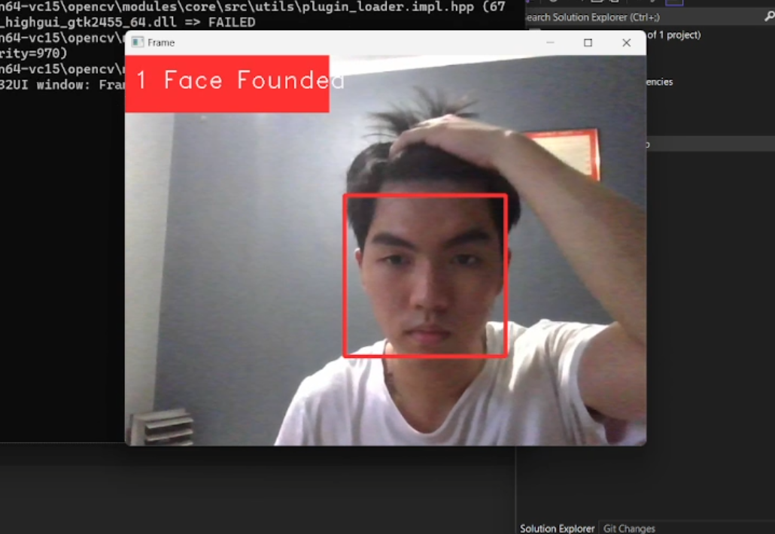



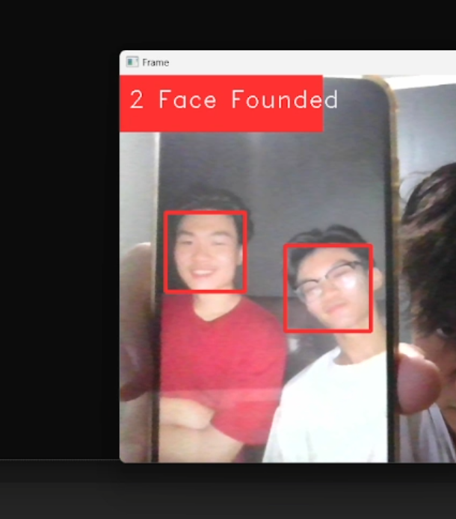

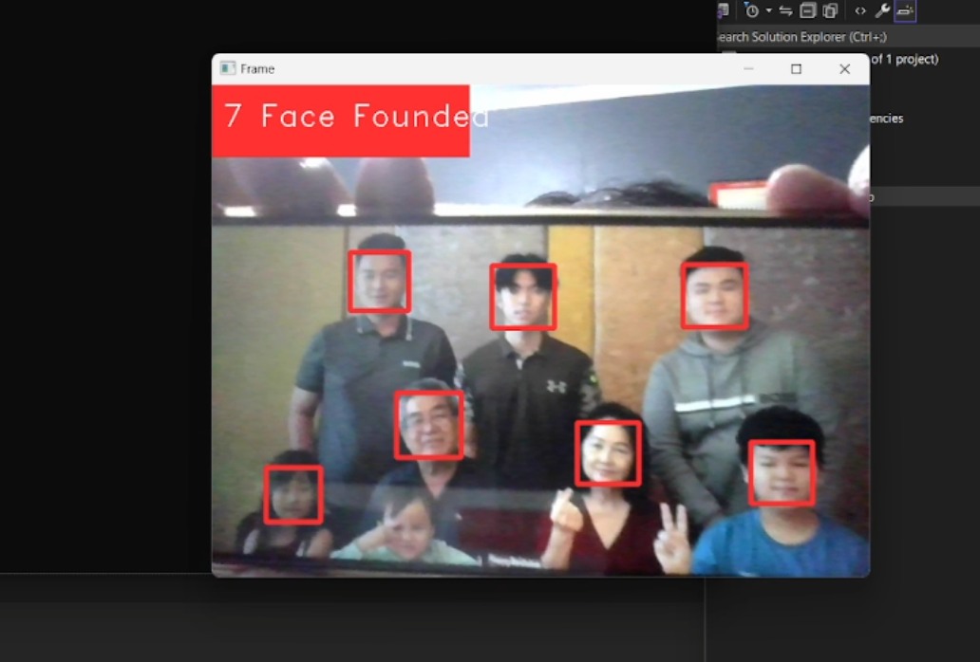

As seen in the pictures above, the model performs quite well as a prototype model, as it can capture more than five faces at the same time. Let's say the success rate is 80%, though in some conditions I've found, the model is quite difficult to detect faces in low-light or high-light surroundings. It also difficult to detect faces that are facing sideways.

Forms response chart. Question title: In your opinion, do you think traditional attendance methods often pose issues such as inefficiency, inaccuracy, etc.
. Number of responses: 32 responses.

Figure 1. In your opinion, do you think traditional attendance methods often pose issues such as inefficiency, inaccuracy, etc.

Based on the above figure, the majority of respondents, amounting to 59.4%, agree that traditional attendance systems have various issues such as inaccuracy, inefficiency, etc. The remaining respondents, 40,6%, disagree that traditional attendance systems have many issues. This indicates that the majority of respondents are less favorable towards traditional attendance methods or using old-fashioned ways and prefer a new attendance process.

Forms response chart. Question title: Do you think traditional attendance processes should be replaced with face recognition technology to facilitate the attendance process?
. Number of responses: 32 responses.

Figure 2. Do you think traditional attendance processes should be replaced with face recognition technology to facilitate the attendance process?

Based on the above figure, the majority of respondents, amounting to 53.1%, agree that traditional attendance systems should be replaced with face recognition technology. The remaining respondents, 46,9%, disagree that traditional attendance systems should be replaced. This indicates that the majority of respondents want the traditional attendance process to be replaced with face recognition technology.

Forms response chart. Question title: In your opinion, does the introduction of face recognition technology for attendance simplify the overall attendance recording process?
. Number of responses: 32 responses.

Figure 3. In your opinion, does the introduction of face recognition technology for attendance simplify the overall attendance recording process?

Based on the above figure, the majority of respondents, amounting to 71.9%, agree that face recognition technology simplifies the attendance recording process. The remaining respondents, 28,1%, disagree that face recognition technology simplifies the attendance recording process. This indicates that the majority of respondents agree that face recognition technology simplifies the attendance recording process.

Forms response chart. Question title: Do you believe that implementing a face recognition program in the attendance process significantly enhances the efficiency and security?
. Number of responses: 32 responses.

Figure 4. Do you believe that implementing a face recognition program in the attendance process significantly enhances the efficiency and security?

Based on the above figure, the majority of respondents, amounting to 81.3%, believe that face recognition technology enhances the efficiency and security in the attendance process. The remaining respondents, 18,8%, do not believe that face recognition technology enhances the efficiency and security in the attendance process. This indicates that the majority of respondents believe that face recognition technology enhances the efficiency and security in the attendance process.

Forms response chart. Question title: In terms of preventing fraudulent activities, do you think a face recognition system is more effective compared to traditional attendance methods?
. Number of responses: 32 responses.

Figure 5. In terms of preventing fraudulent activities, do you think a face recognition system is more effective compared to traditional attendance methods?

Based on the above figure, the majority of respondents, amounting to 81.3%, believe that the face recognition system is more effective compared to traditional attendance methods. The remaining respondents, 18,8%, do not believe that the face recognition system is more effective compared to traditional attendance methods. This indicates that the majority of respondents believe that the face recognition system is more effective compared to traditional attendance methods.

Forms response chart. Question title: Considering concerns related to privacy, do you feel comfortable with the use of face recognition for attendance tracking in your institution or workplace?
. Number of responses: 32 responses.

Figure 6. Considering concerns related to privacy, do you feel comfortable with the use of face recognition for attendance tracking in your institution or workplace?

Based on the above figure, the majority of respondents, amounting to 62,5%, feel comfortable with the use of face recognition for attendance tracking in your institution or workplace. The remaining respondents, 37,5%, do not feel comfortable with the use of face recognition for attendance tracking in your institution or workplace. This indicates that the majority of respondents still feel comfortable with the use of face recognition for attendance tracking in your institution or workplace.

Forms response chart. Question title: In your experience, does the accuracy and speed of face recognition technology justify its integration into the attendance system, or do you find it to be unnecessary?
. Number of responses: 32 responses.

Figure 7. In your experience, does the accuracy and speed of face recognition technology justify its integration into the attendance system, or do you find it to be unnecessary?

According to the illustrated data, a predominant 81.3% of participants express the conviction that the precision and expeditiousness exhibited by face recognition technology warrant its seamless incorporation into the attendance system. In contrast, the residual 18.8% of respondents harbor reservations regarding the justification of integrating face recognition technology into the attendance system based on its accuracy and speed. This observation suggests that the prevailing sentiment among respondents leans towards the endorsement of integrating face recognition technology into the attendance system, owing to its perceived accuracy and speed.

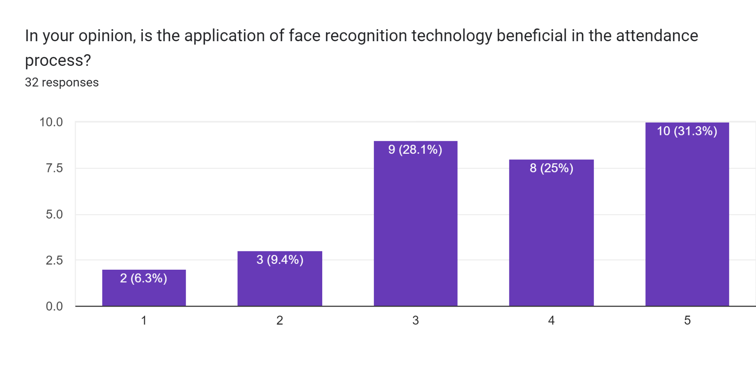

Figure 8. In your opinion, is the application of face recognition technology beneficial in the attendance process?

A survey of 32 people found that 31.3% believe face recognition technology is strongly beneficial for attendance tracking, followed by 28.1% who find it somewhat beneficial. A quarter (25.0%) find it not very beneficial, and only 6.3% find it not beneficial at all. These results suggest face recognition is generally seen as a positive tool for attendance, though some concerns exist.

**5. CONCLUSION**

Face recognition technology, a sophisticated innovation designed to identify individuals based on their distinctive facial features, has become a linchpin in modern solutions across diverse sectors. Its seamless integration into attendance management processes signifies a paradigm shift from conventional methodologies. Organizations, in their quest for operational efficiency and accuracy, are increasingly recognizing the transformative potential of adopting this advanced technology.

The strategic implementation of face recognition technology offers a multitude of advantages in addressing prevalent challenges associated with attendance tracking. By proactively tackling issues such as fraudulent activities, inaccuracies stemming from manual record-keeping, inefficiencies inherent in outdated systems, and the overall ineffectiveness of traditional methods, it presents a comprehensive solution to streamline attendance processes. This technology not only fortifies the security and integrity of attendance records but also introduces a layer of automation that significantly reduces the margin for error.

When executed with precision, face recognition technology introduces a new era of reliability and resource optimization. Its nuanced analysis of facial features ensures robust identity verification, mitigating risks of impersonation and fraudulent clock-ins. The efficiency gains achieved through automation empower organizations to redirect their focus toward strategic initiatives. In essence, face recognition technology emerges as a pivotal instrument reshaping the landscape of attendance management, offering a future where precision, security, and operational excellence converge to meet the demands of modern workflows.

**REFERENCE**

[1] Barney, N., & Bernstein, C. (2023, April 20). What is face detection and how does it work?. Enterprise AI. https://www.techtarget.com/searchenterpriseai/definition/face-detection

[2] Chusna, F. (2023, May 3). Apa Itu Face Recognition? Pengertian, Cara Kerja, Fungsi. Privy Blog. https://blog.privy.id/face-recognition/

[3] Facial recognition technology - innovatrics - how it works. Innovatrics. (2023, December 7). https://www.innovatrics.com/facial-recognition-technology/

[4] Google. (n.d.). Face detection | ML kit | google for developers. Google. https://developers.google.com/ml-kit/vision/face-detection

[5] Nodeflux. (2023, April 26). Teknologi face recognition: Cara Kerja, Manfaat & Contohnya. https://www.visionaire.ai/post/mengenal-teknologi-face-recognition-system

[6] Pertiwi, W. K. (2022, April 14). Apa Itu Teknologi Face recognition Dan Bagaimana Cara Kerjanya? Halaman all. KOMPAS.com. https://tekno.kompas.com/read/2022/04/14/17050047/apa-itu-teknologi-face-recognition-dan-bagaimana-cara-kerjanya-?page=all

[7] The University. (1978). What is ... Amazon. https://aws.amazon.com/what-is/facial-recognition/

[8] Verihubs-Writer. (2023, May 1). Teknologi face matching Dalam proses face recognition system. Verihubs. https://verihubs.com/blog/face-matching/